長庚大學資訊工程學系 一百零九學年度上學期 計算機圖學課程 作業 II
上課班級: 三年甲班 授課老師: 林俊淵
作業範圍: Geometric Transformations

- Please write an OpenGL program to draw the picture according to the following steps. (50 points)

Step 1: please set and draw an original object as the figure 1.a.
(windows size and projection plane both are 400 x 400, object vertices are {50.0, 300.0}, {150.0, 300.0}, {200.0, 350.0}, {100.0, 400.0}, {0.0, 350})
Step 2: find the centriod point PA for the object.
Step 3: use the centroid point PA as a fixed point to do the scaling with sx=sy=1.5.
Step 4: use the centroid point PA as a pivot point to do the rotation with angle -180∘.
Step 5: do the translation with tx= 150, ty= -100.
Step 6: find the centroid point PB for the object after step 5.
Step 7: use the centroid point PB as a pivot point to do the rotation with angle 90∘.
Step 8: use the centroid point PB as a fixed point to do the scaling with sx=sy=0.5.
Step 9: do the translation with tx= 100, ty= -100.
Step 10: draw the object after Step 9 with red color. (using feasible projection plane)

- Please write an OpenGL program to draw the picture according to the following steps. (50 points)

Step 1: please set and draw an original object as the figure 2.a. (windows size and projection plane both are 400 x 400, object center is {100, 100} and the radius of object is 100)
Step 2: find the centriod point PA for the object.
Step 3: use the centroid point PA as a fixed point to do the scaling with sx=sy=2.0.
Step 4: do the translation with tx= 150, ty= 50.
Step 5: draw the object after Step 4 with blue color. (using fessible projection plane)

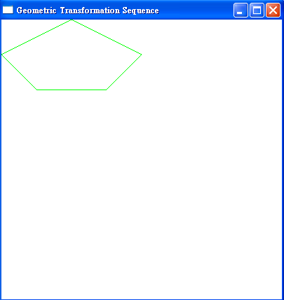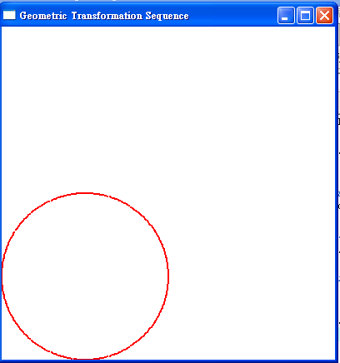
Figure 1.a Figure 2.a

Please send (or ftp) the Source code (*.c or *.cpp) and Executable file (.exe) to me (cyulin@mail.cgu.edu.tw) before 12/28, 23:59. Please annotate your name and your student ID in email. The file name is “student ID”. If more than one files, the names are “student ID-1”, “student ID-2”, etc. Please compress the file(s) to a .zip or .rar file. The file name is “student ID-HW2”. The files will be rejected without following the rules.

